Name : Nicholas Ho

NIM : 2702287541

Class : LC01

**Documentation JeniusAcademy**

1. **All Pages**
2. Navbar
3. Figma



1. Website

* Above 768px



* 768px and lower



1. Footer
2. Figma

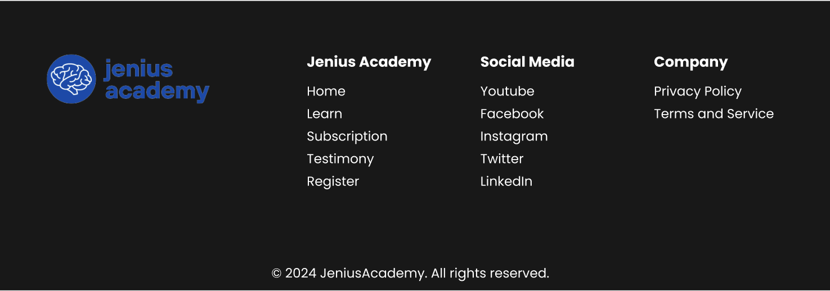

1. Website

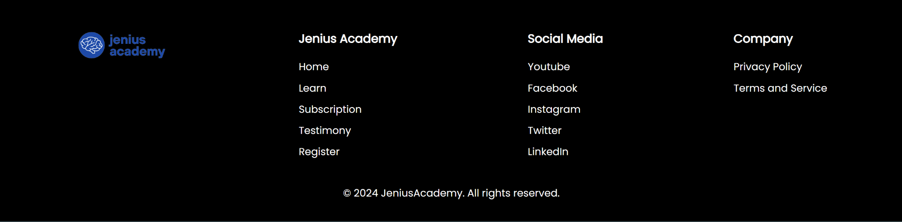

1. Home Page
2. Figma

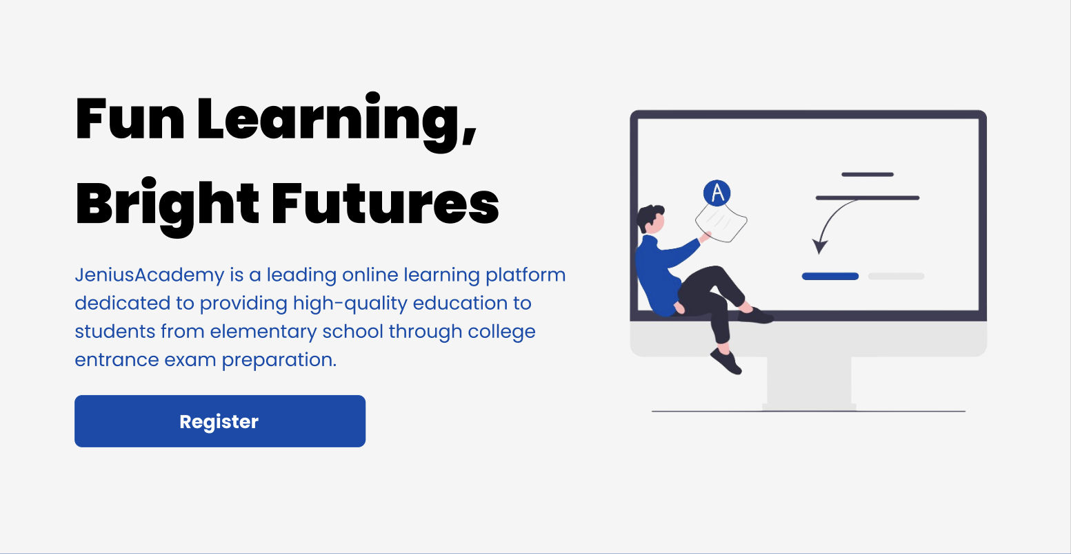

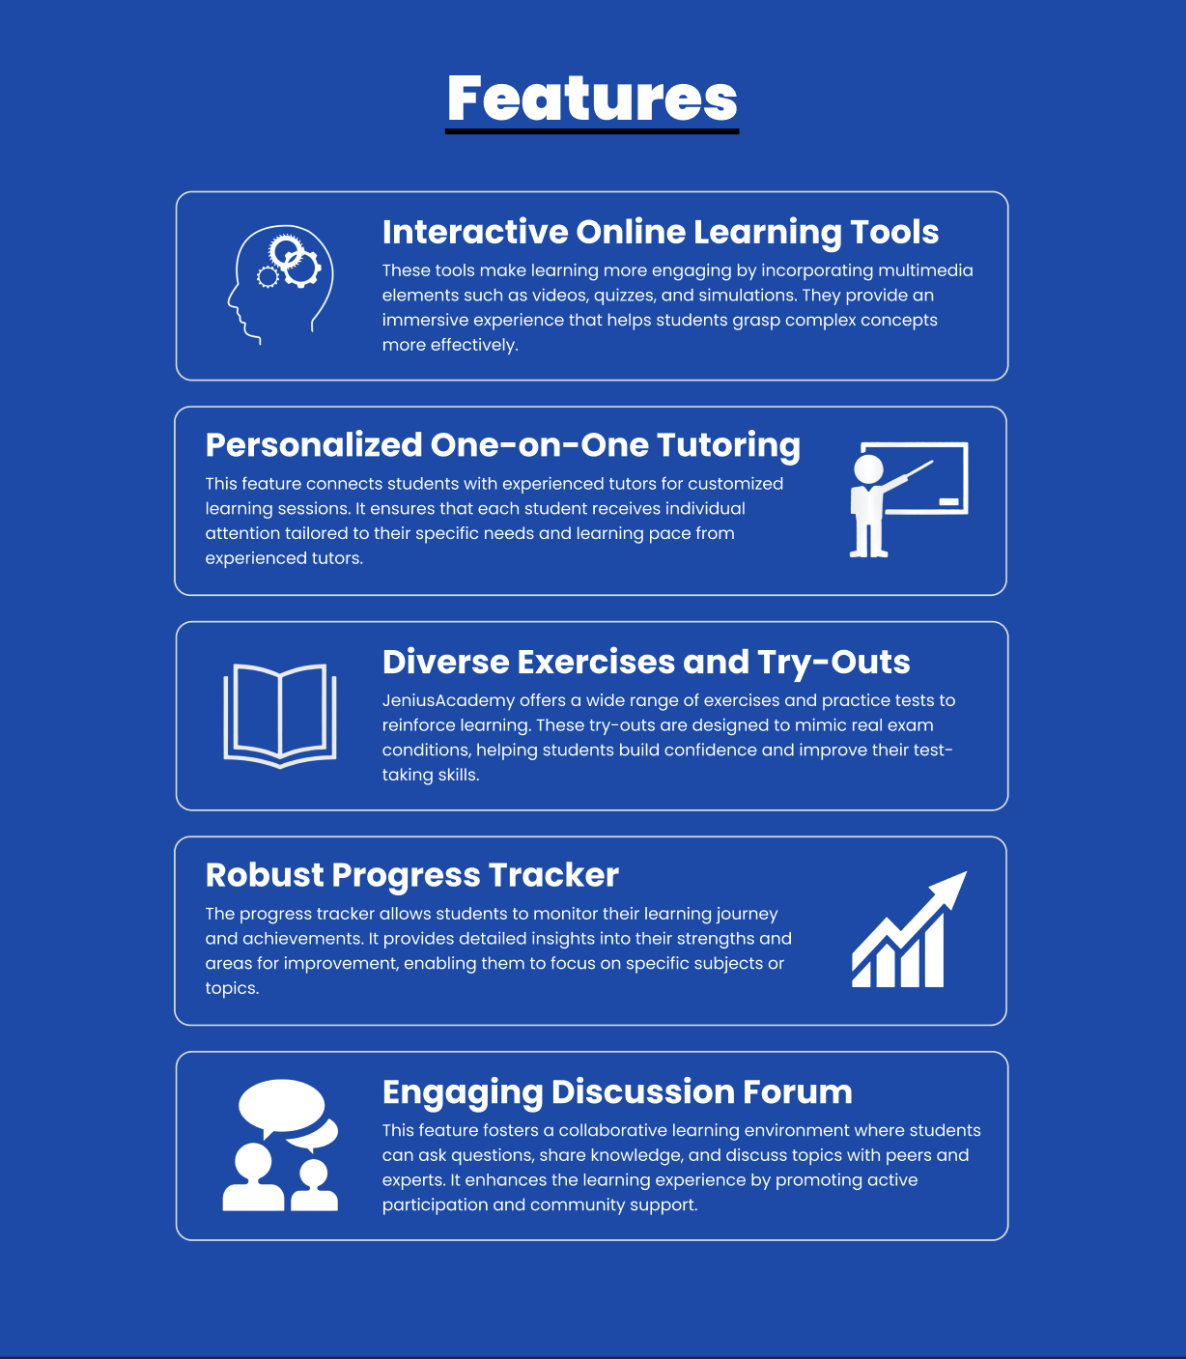

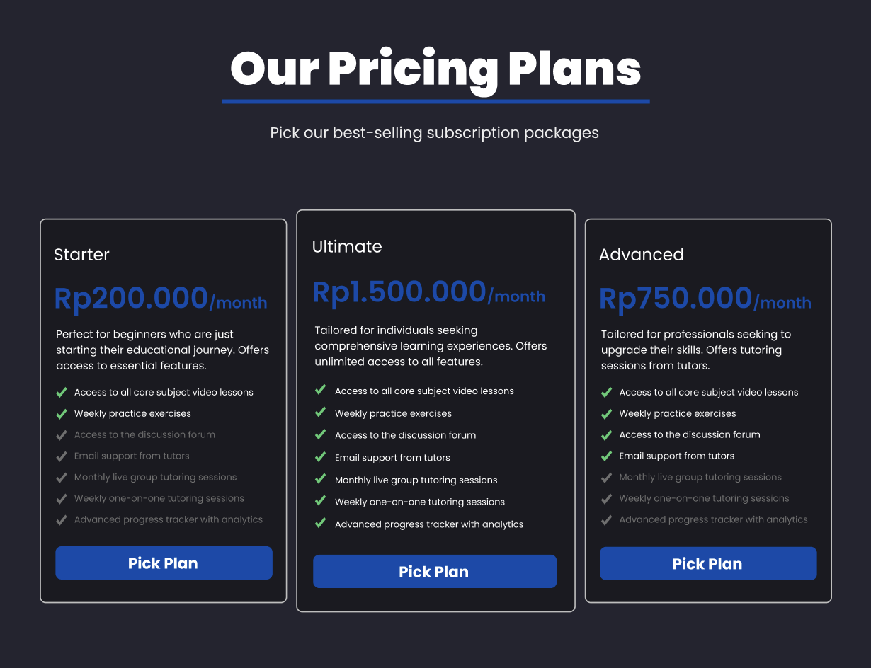

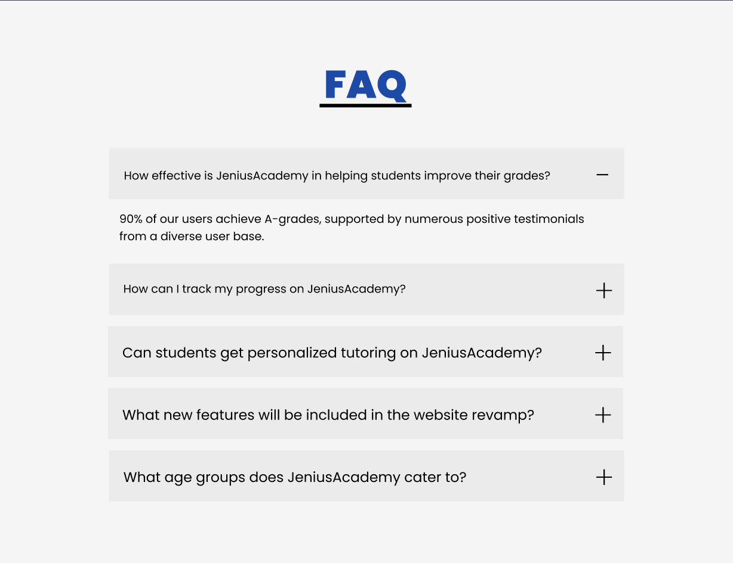

1. Website

* Above 1200px

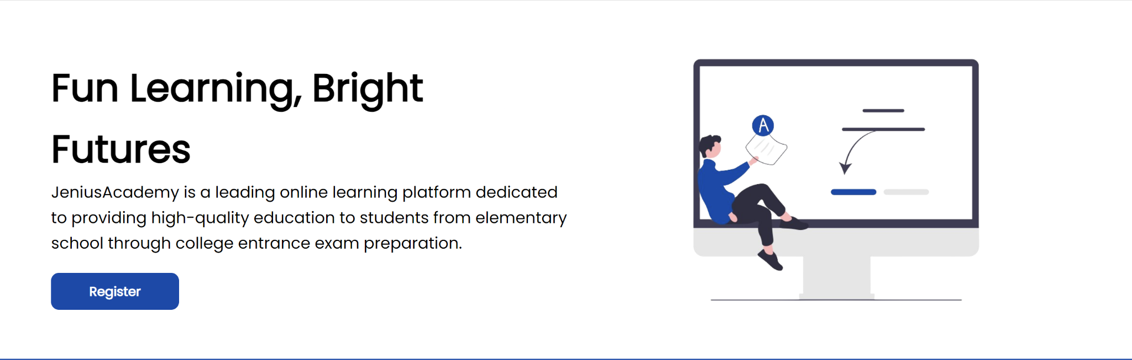

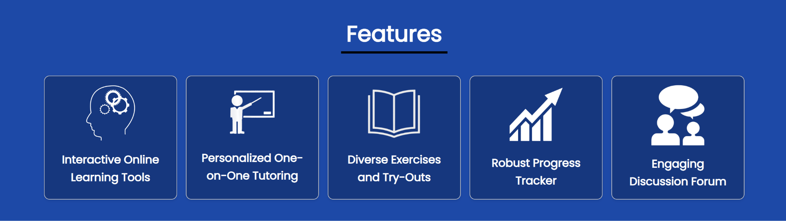

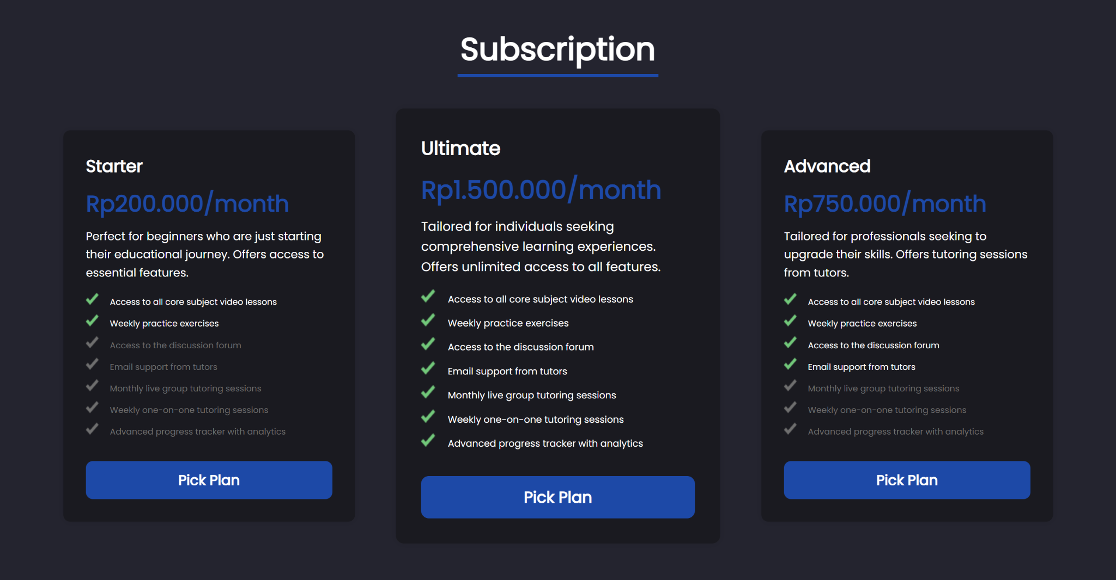

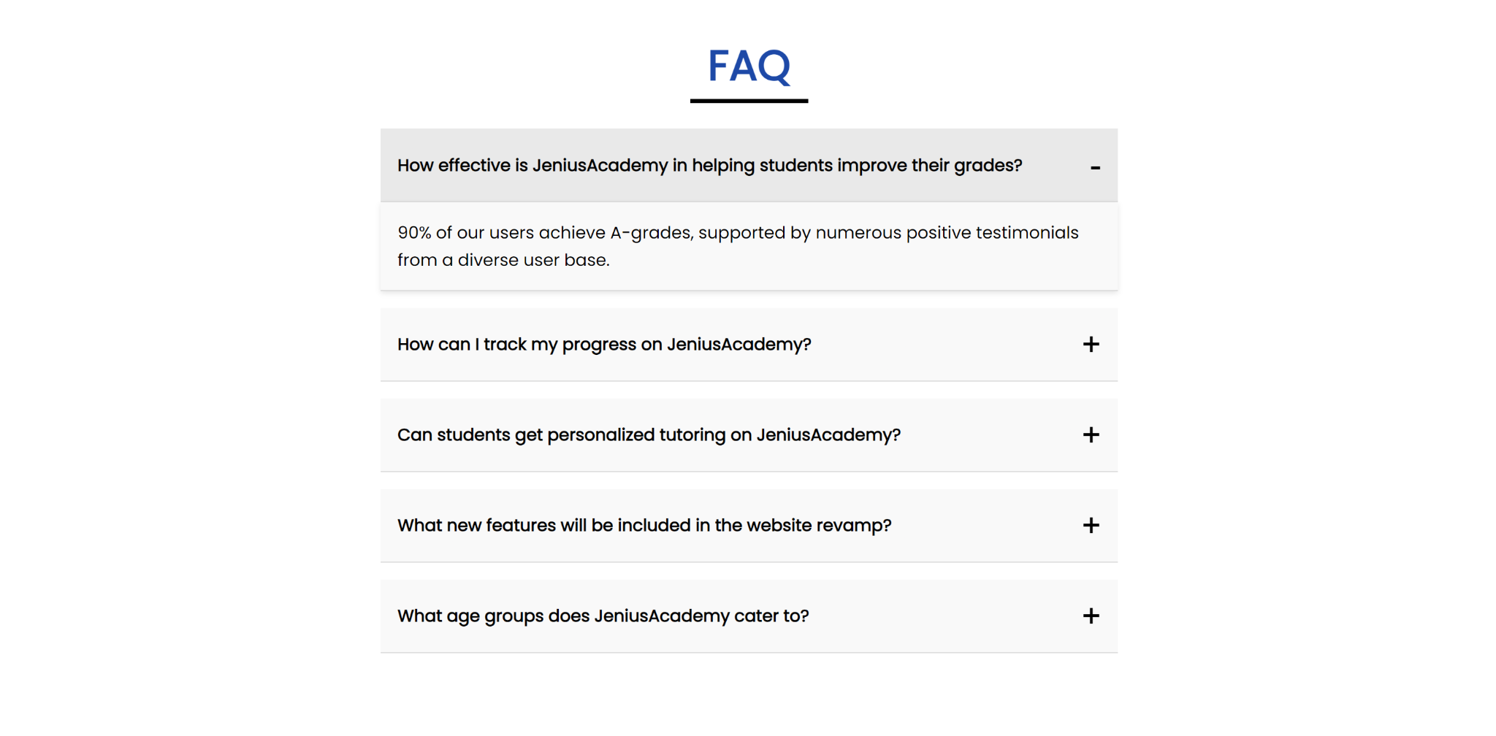

* 769-1200px

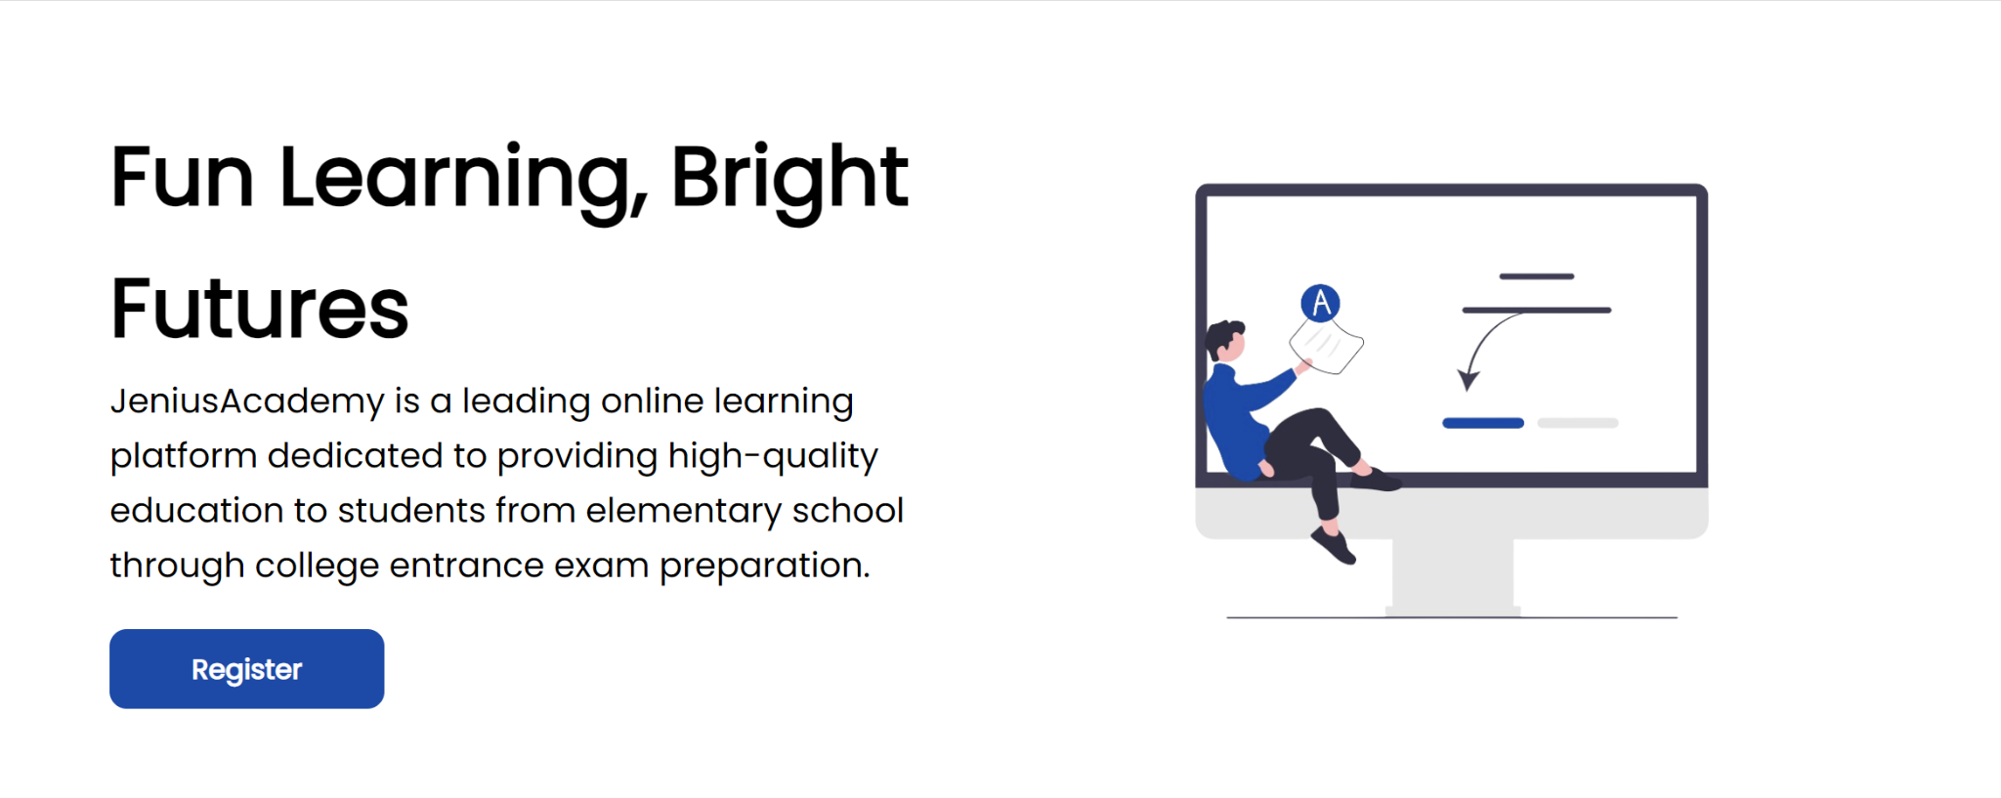

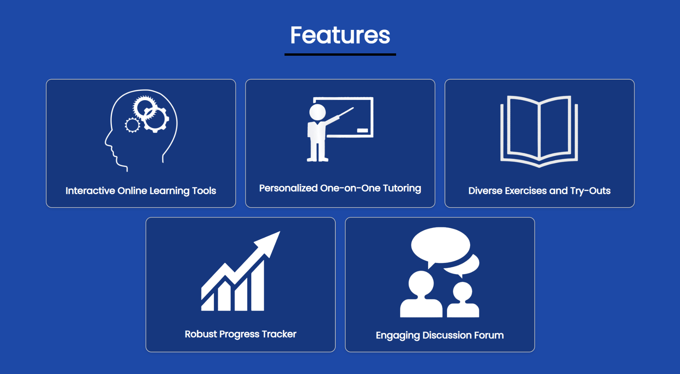

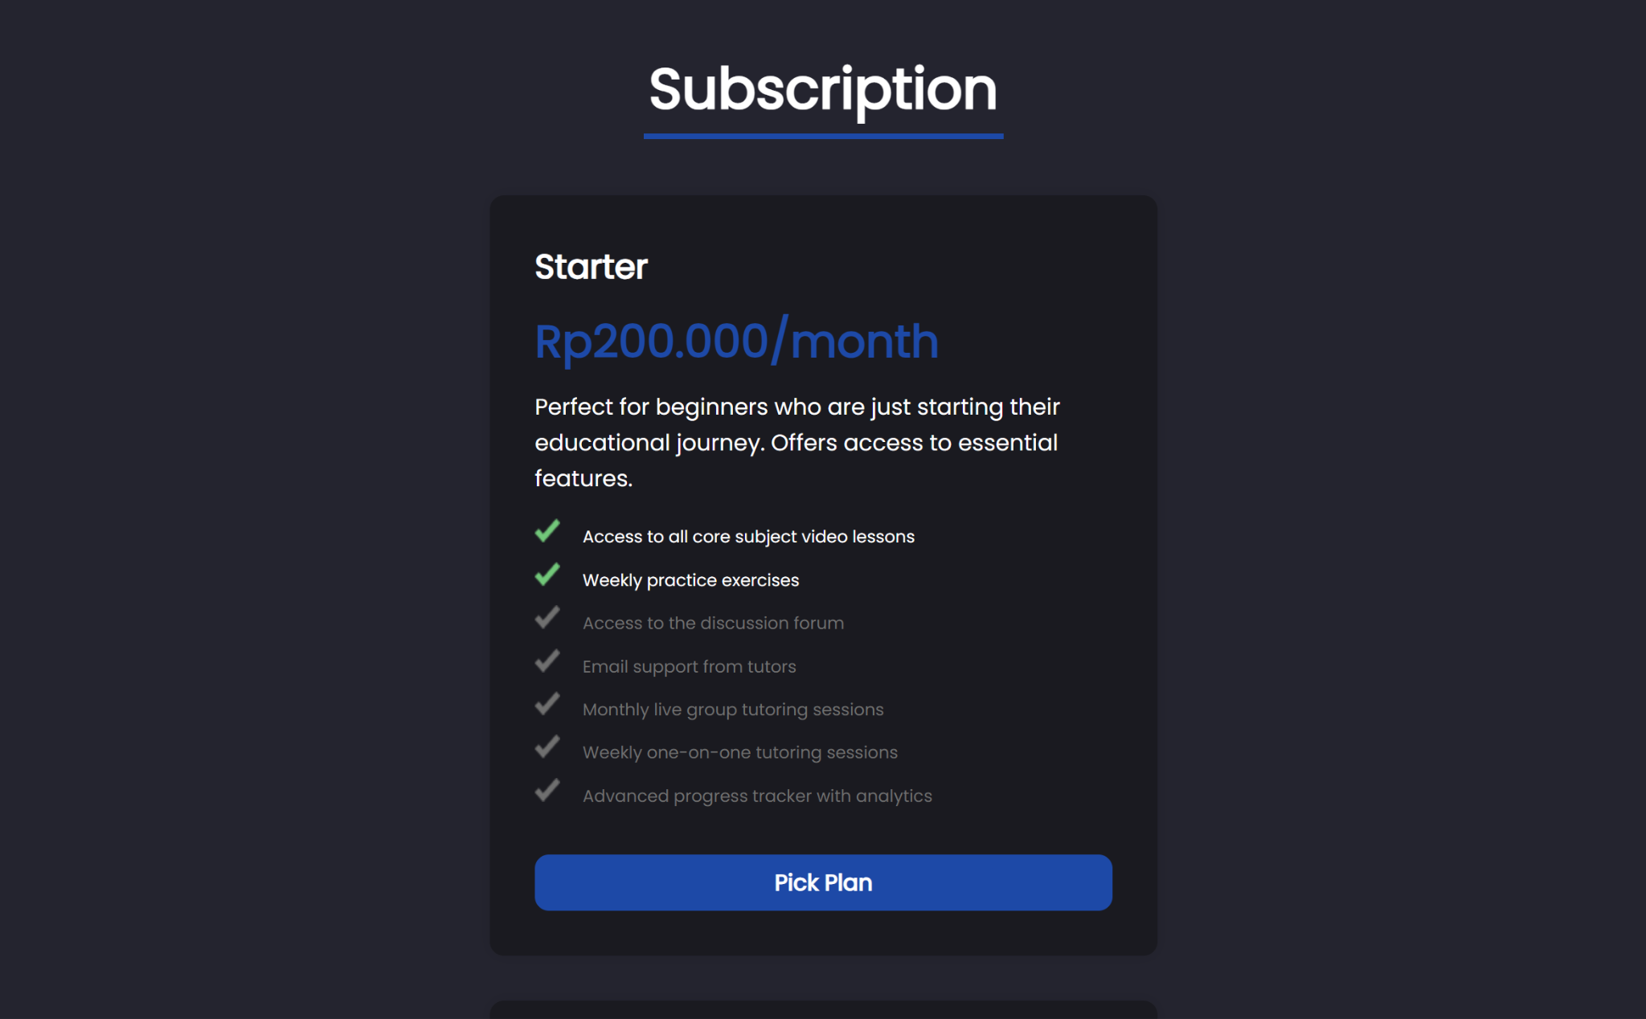

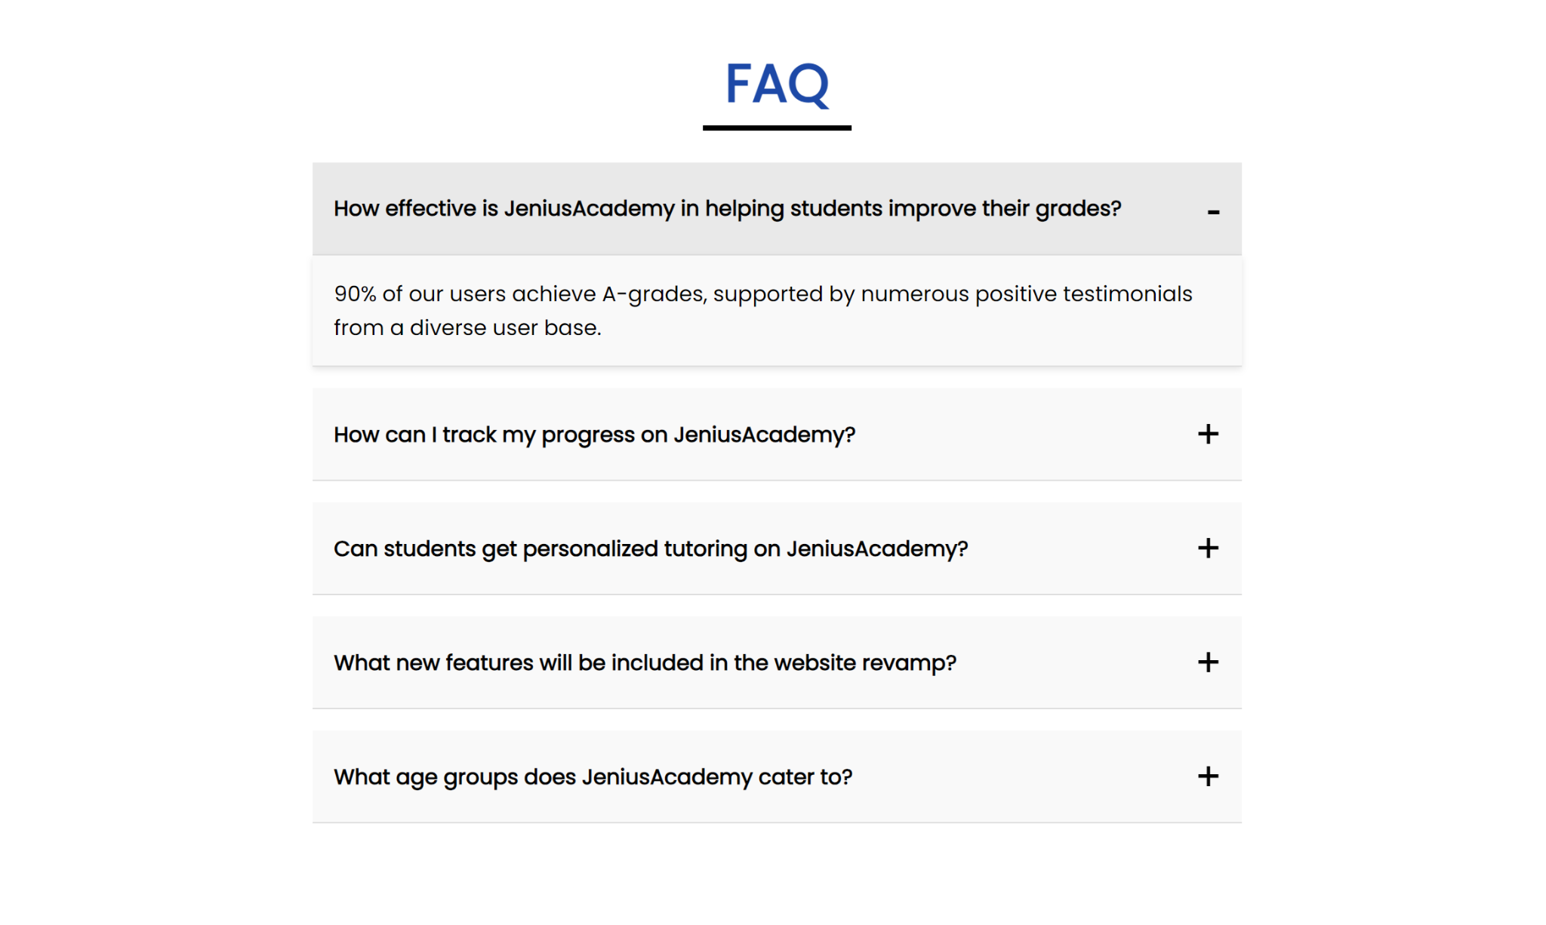

* 768px and lower

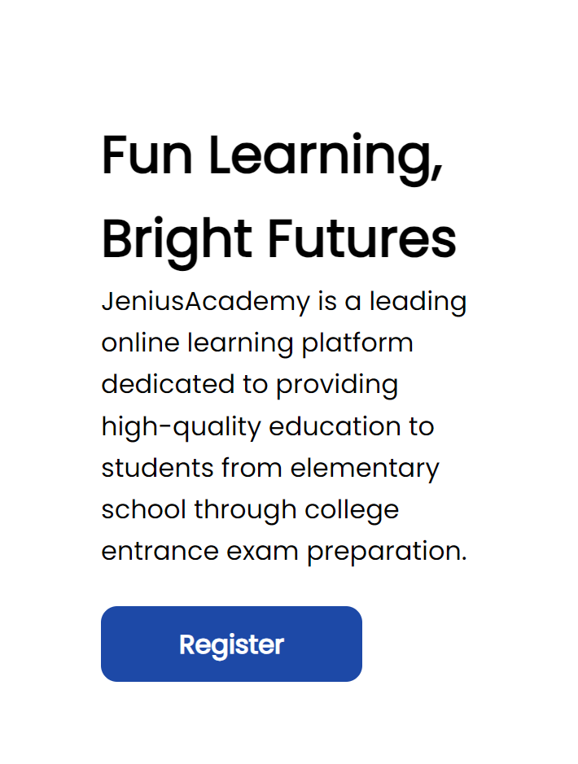

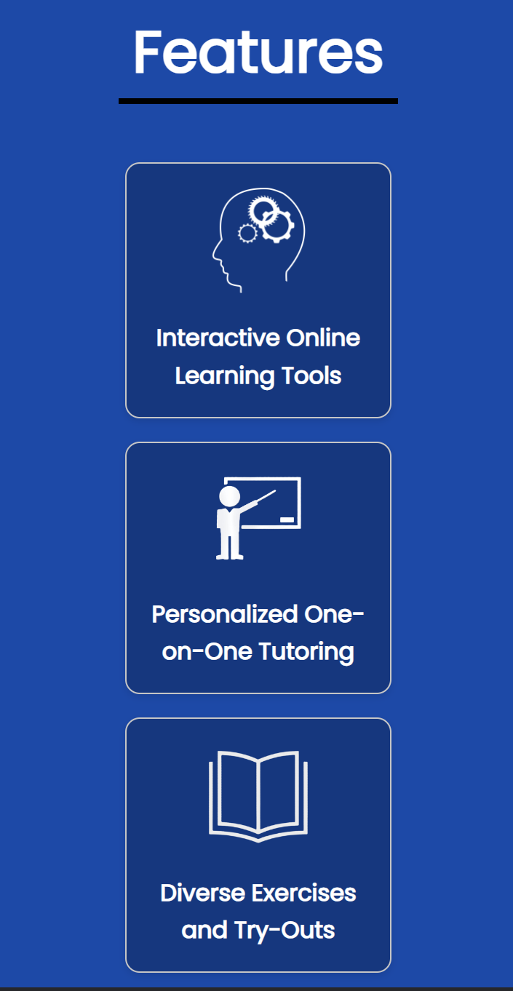

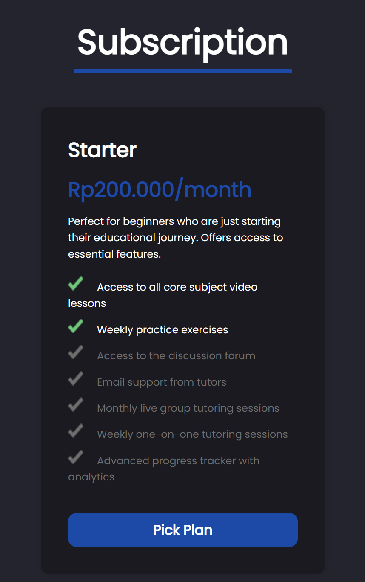

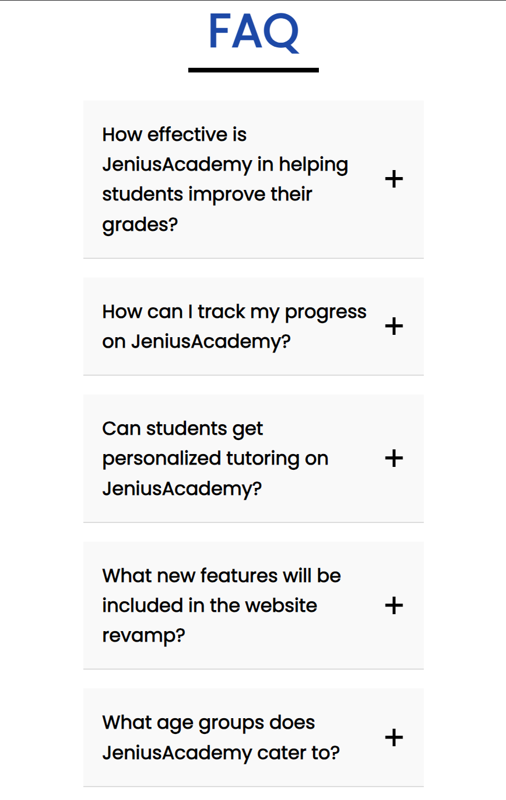

1. Learn Page
2. Figma

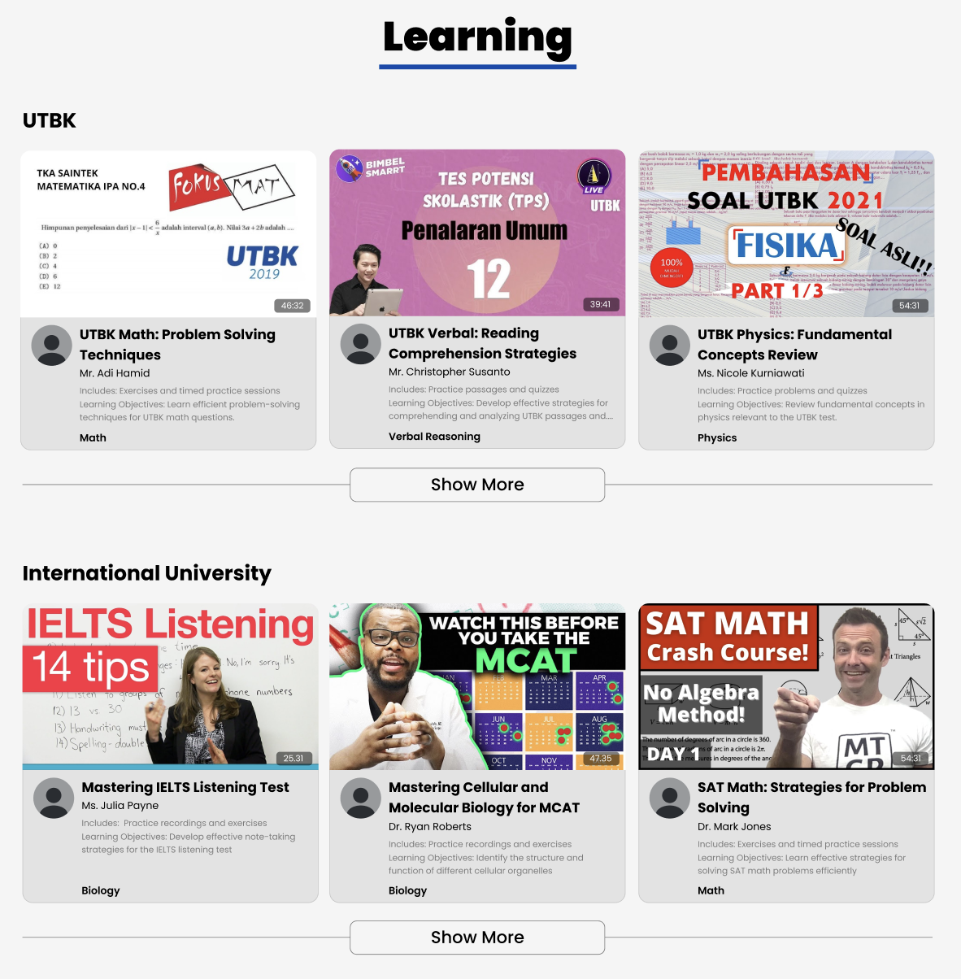

1. Website

* Above 1200px

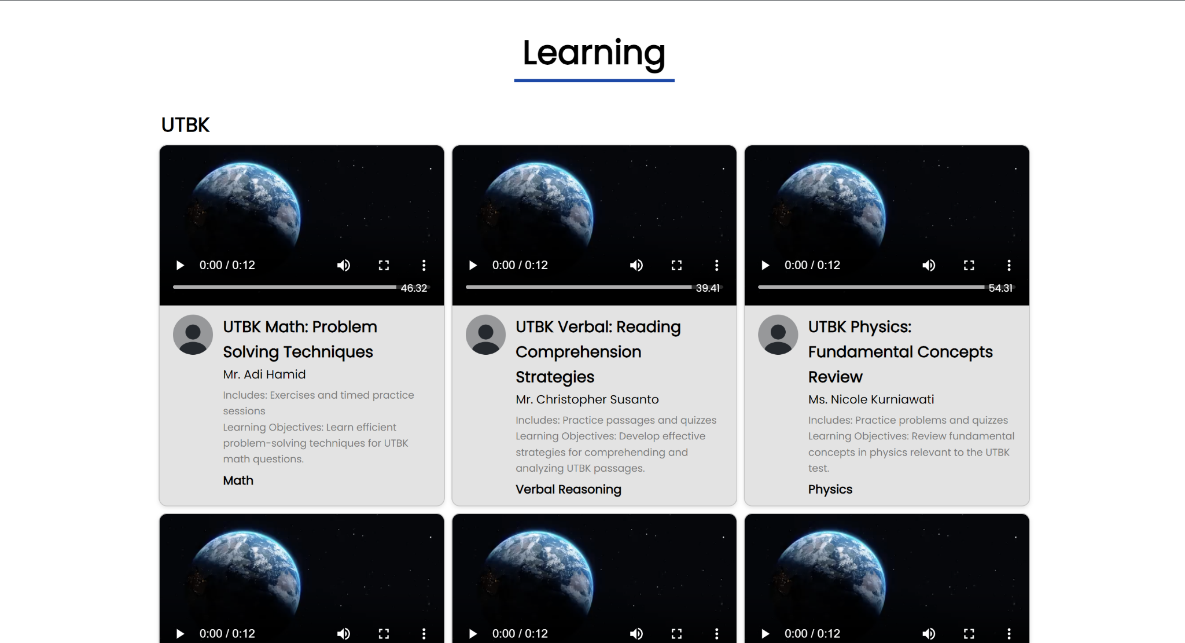

* 769-1200px

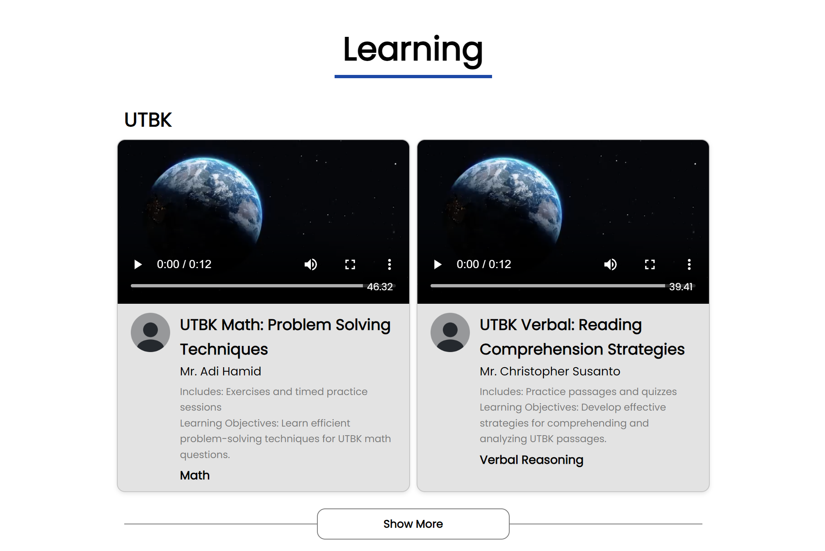

* 768px and lower

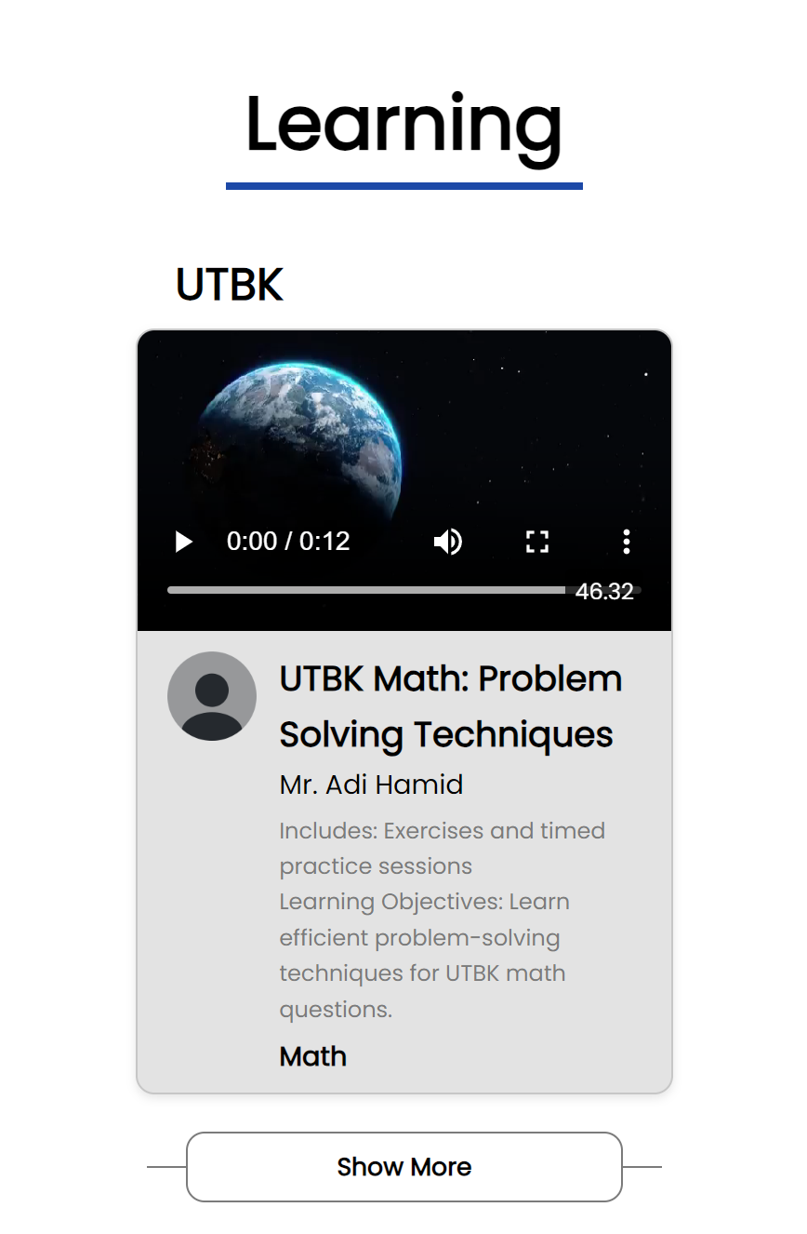

1. Subscription Page
2. Figma

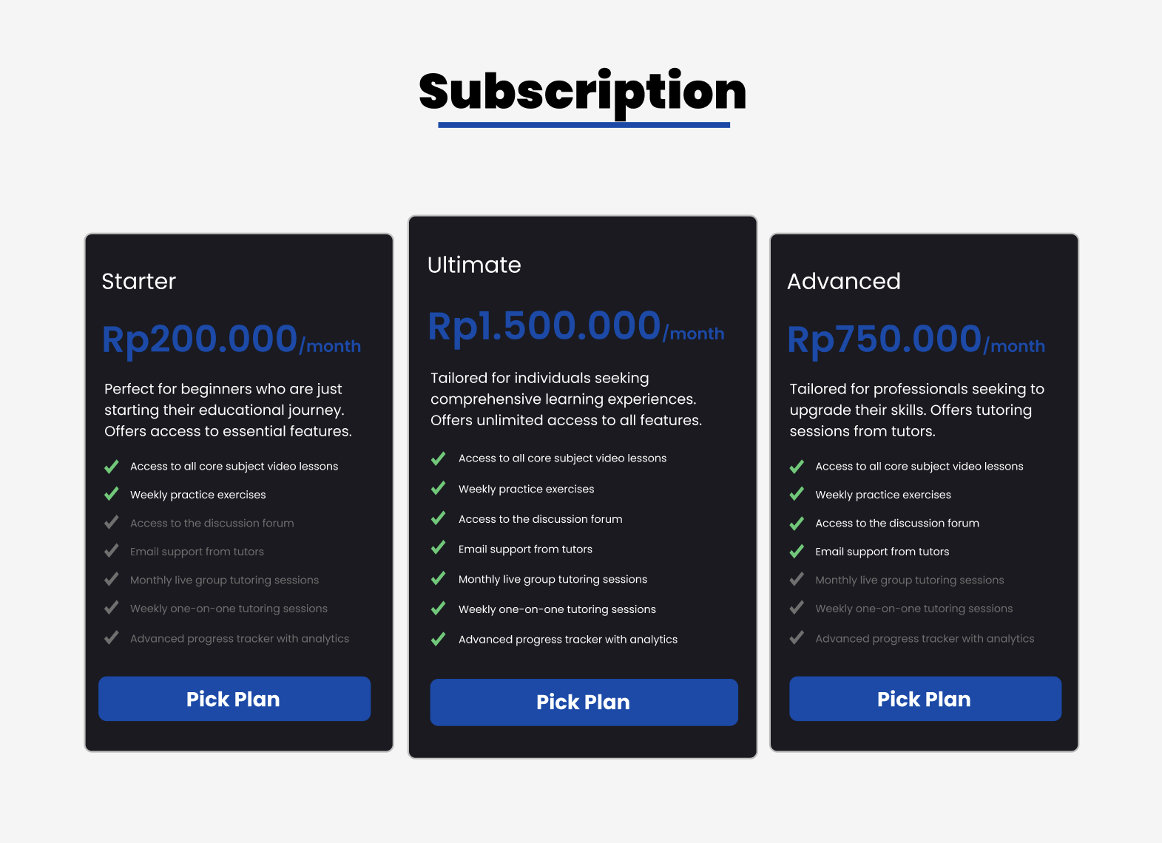

1. Website

* Above 1200px

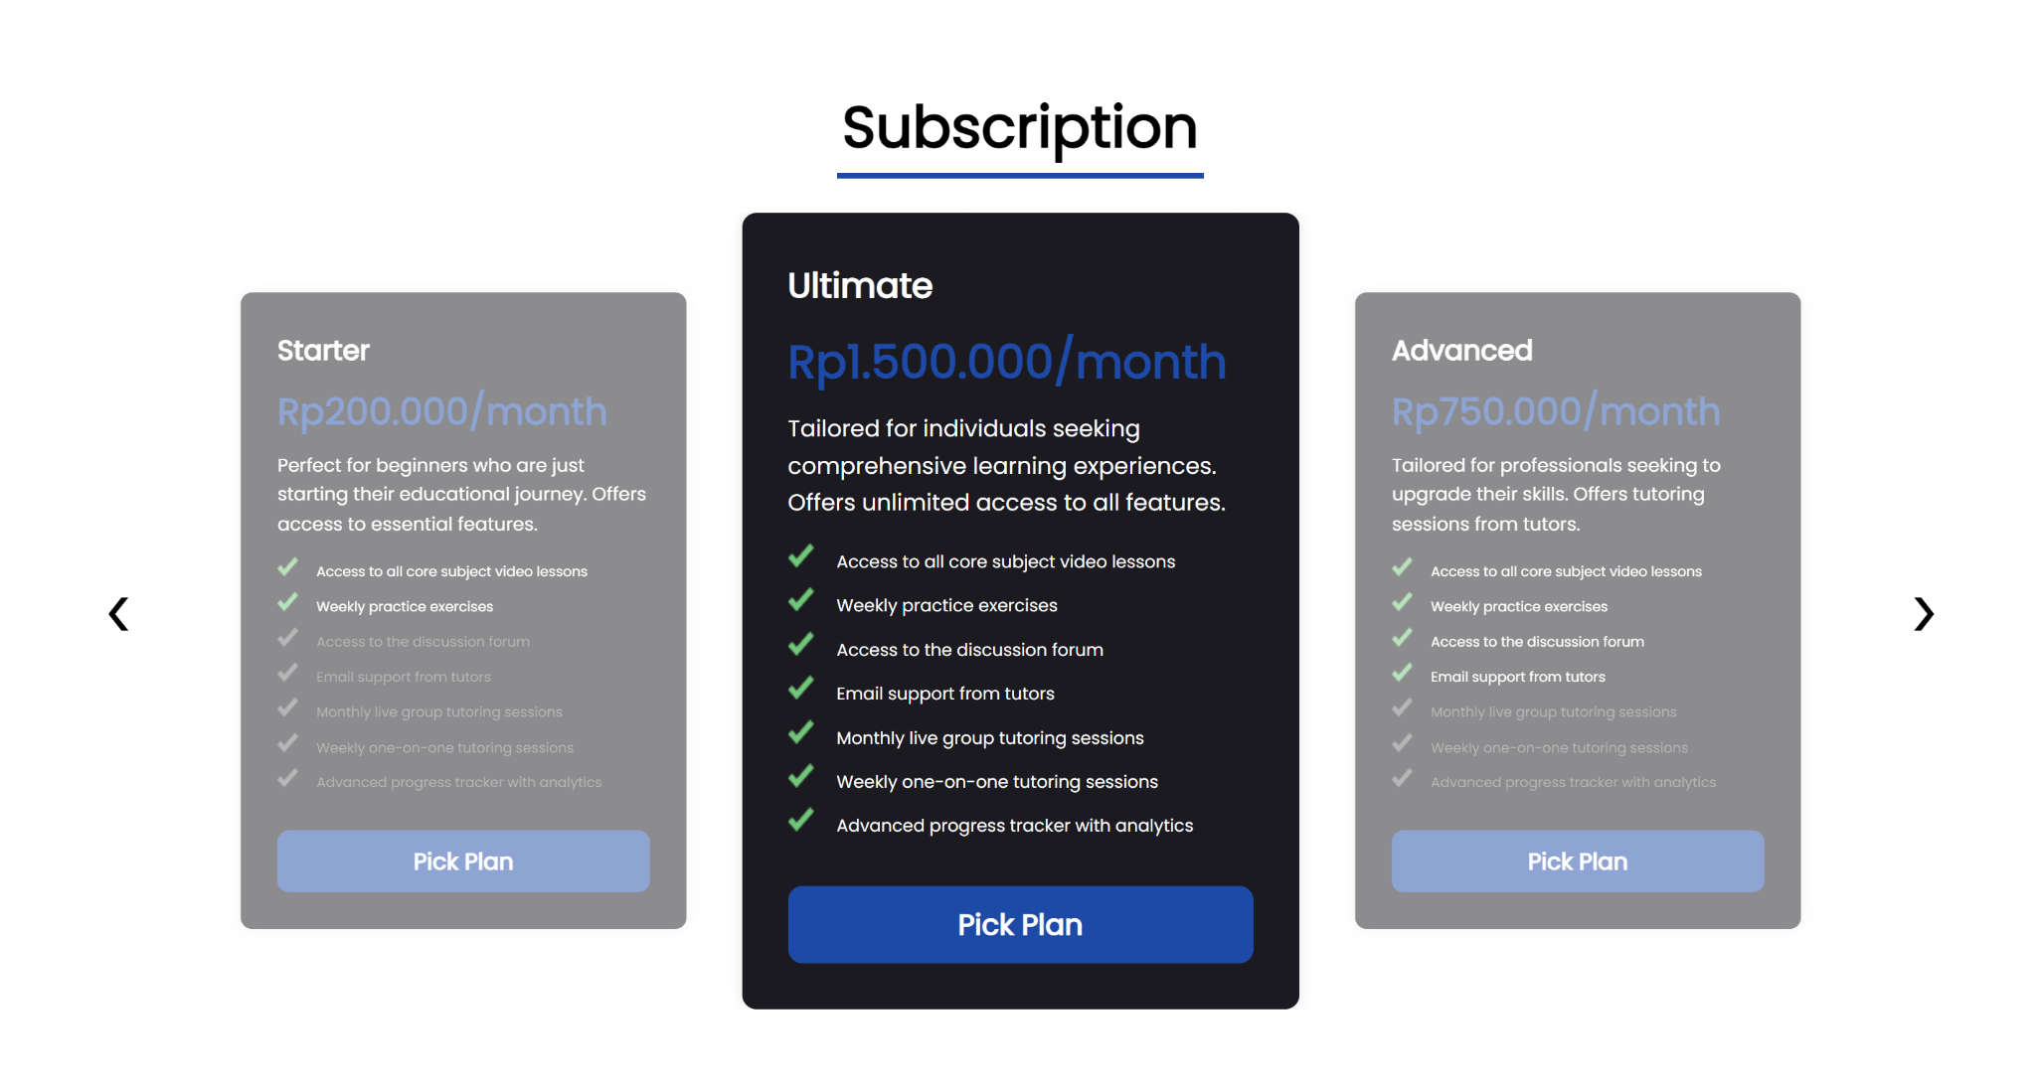

* 1200px and lower

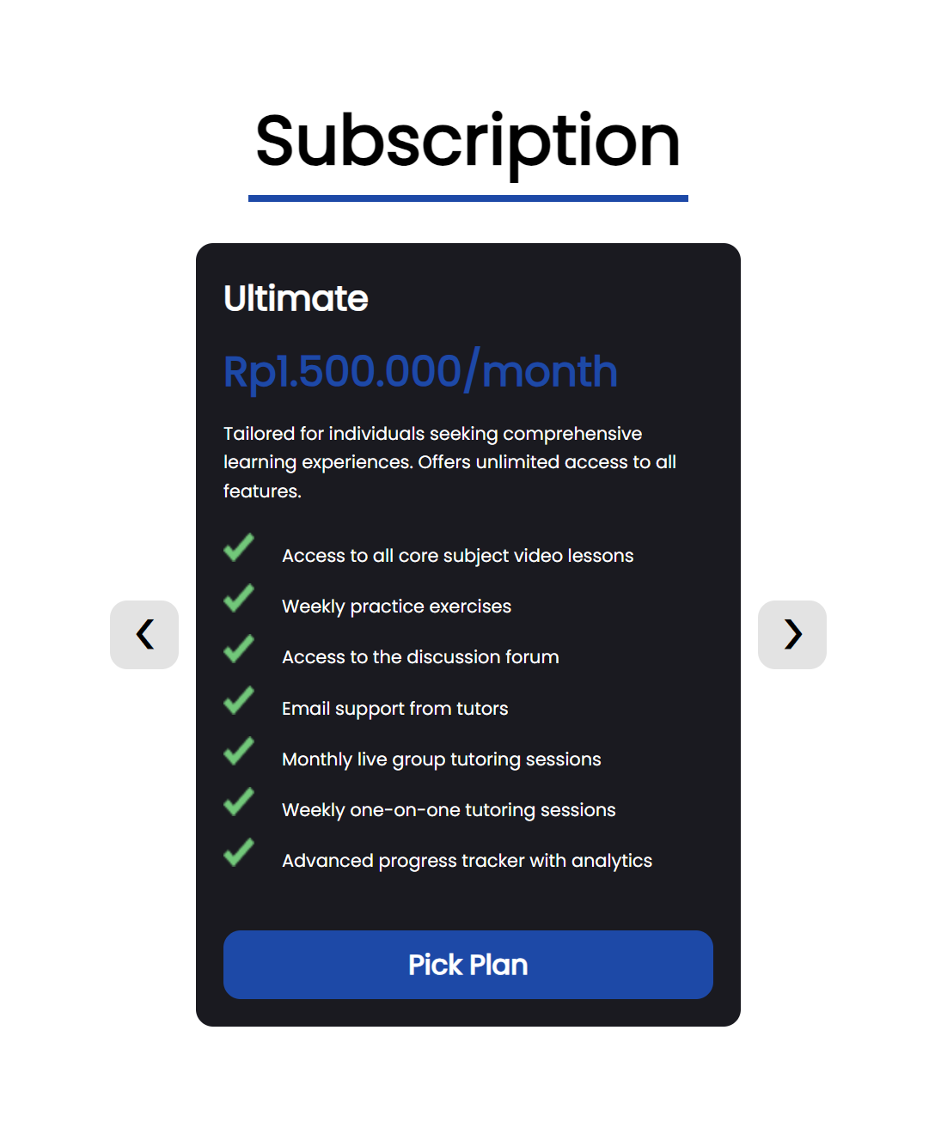

1. Testimony Page
2. Figma

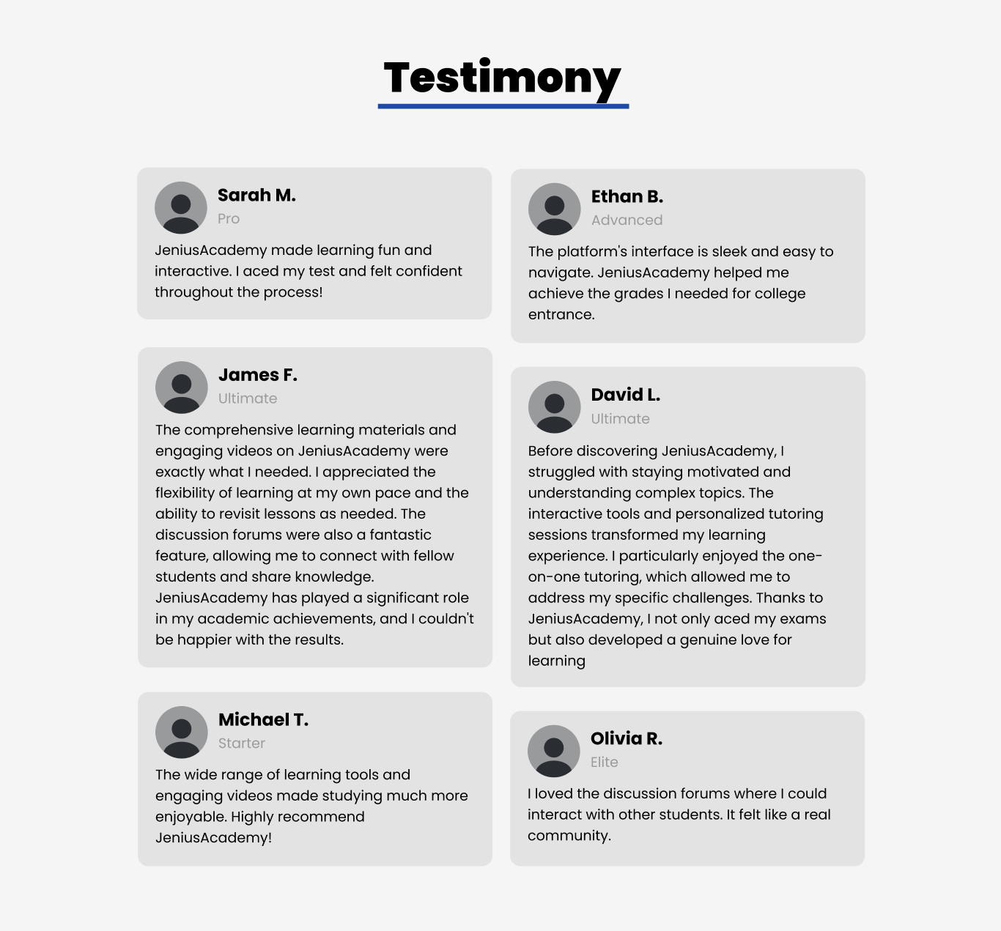

1. Website

* Above 1200px

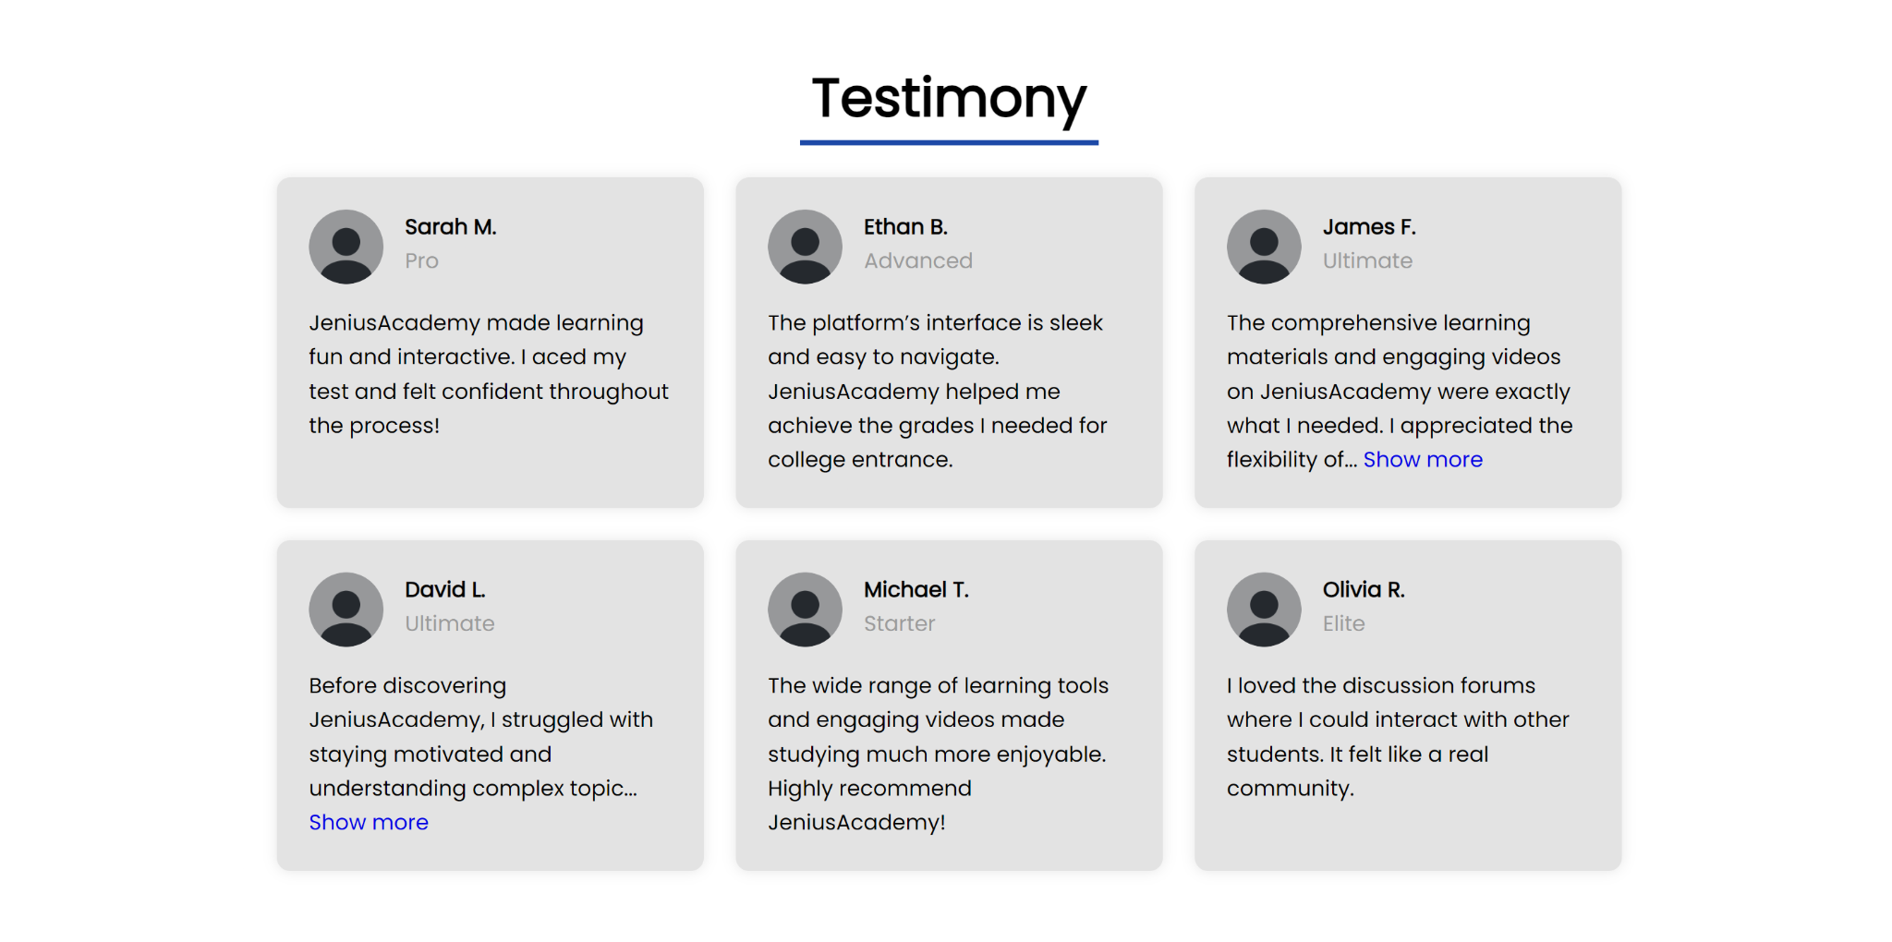

* 769-1200px

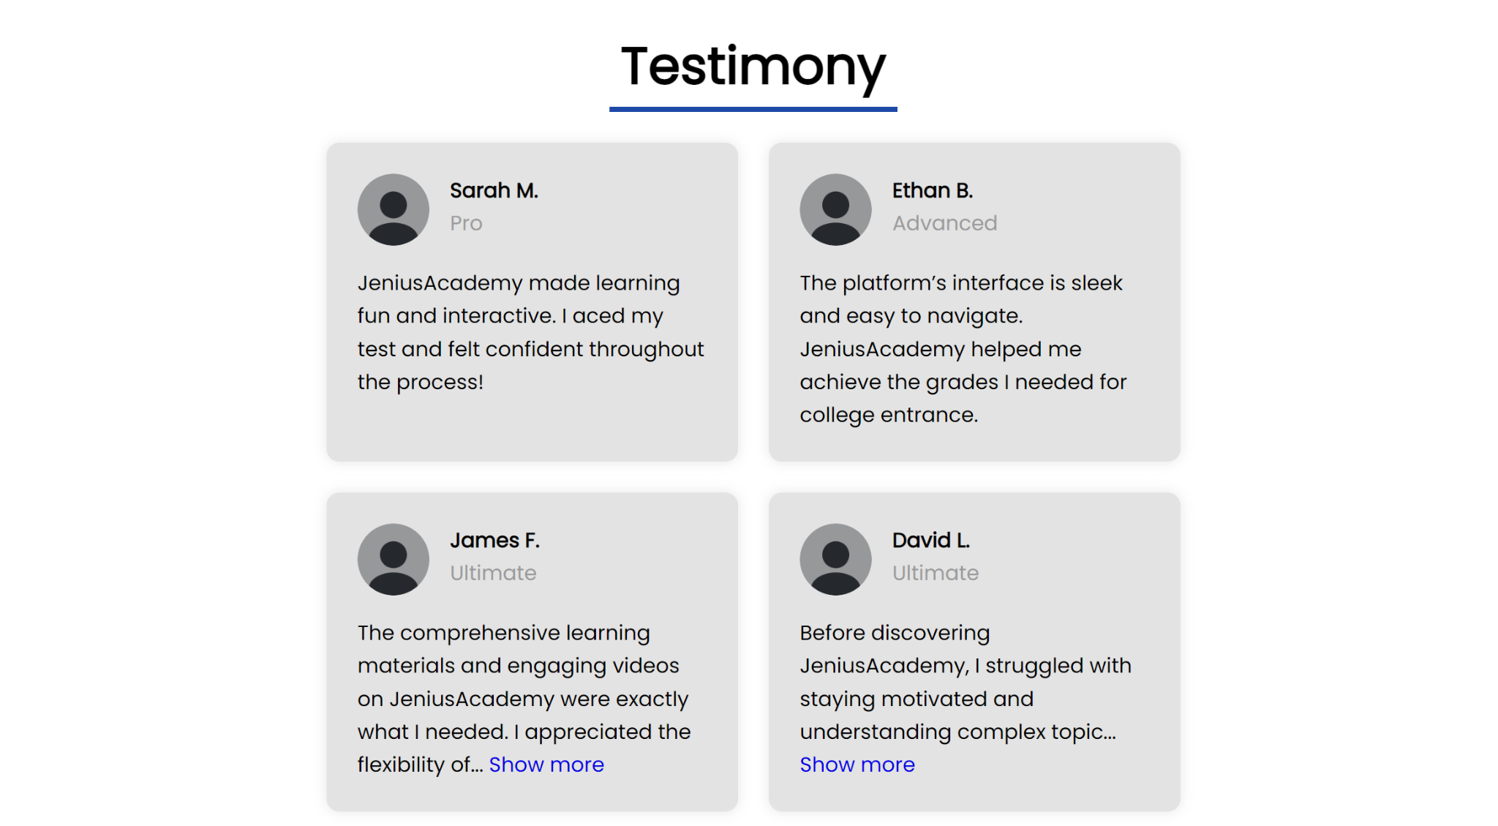

* 768px and lower

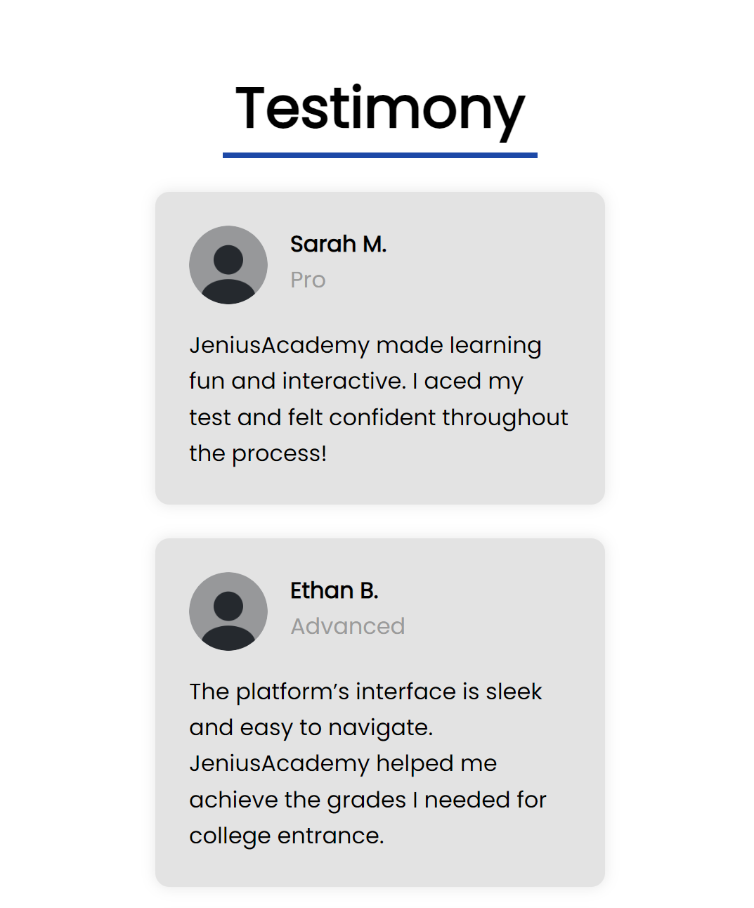

1. Register Page
   1. Figma

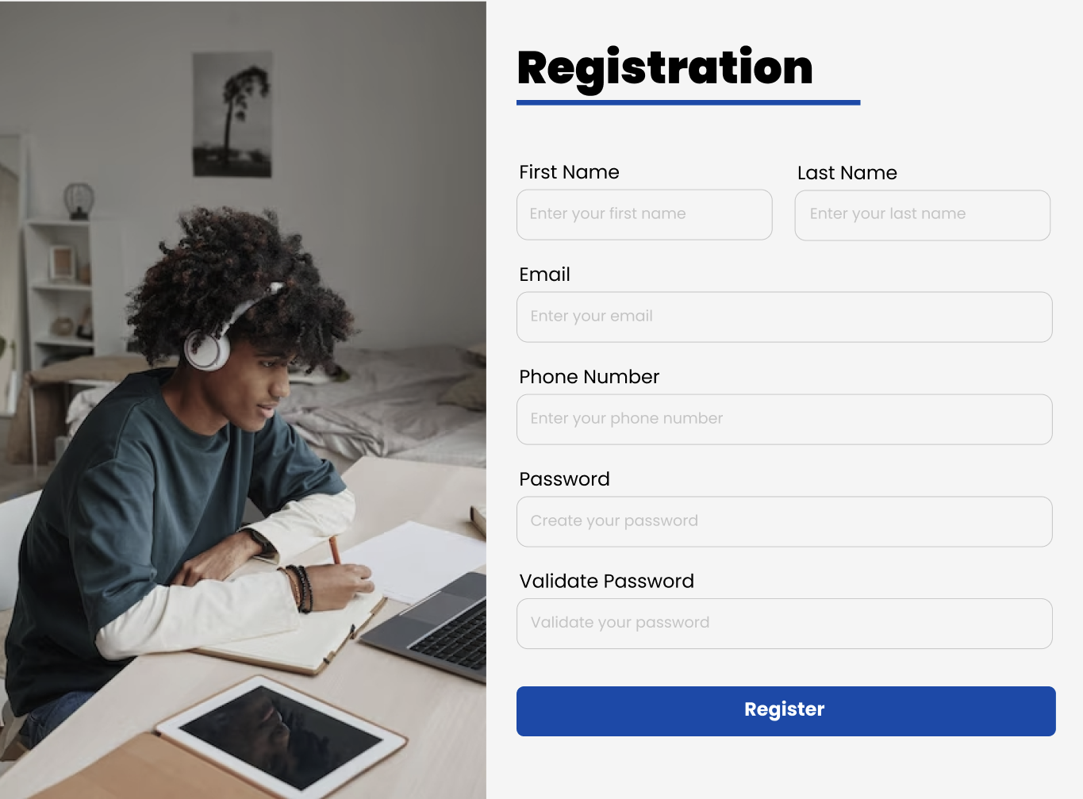

* 1. Website
* Above 1200px

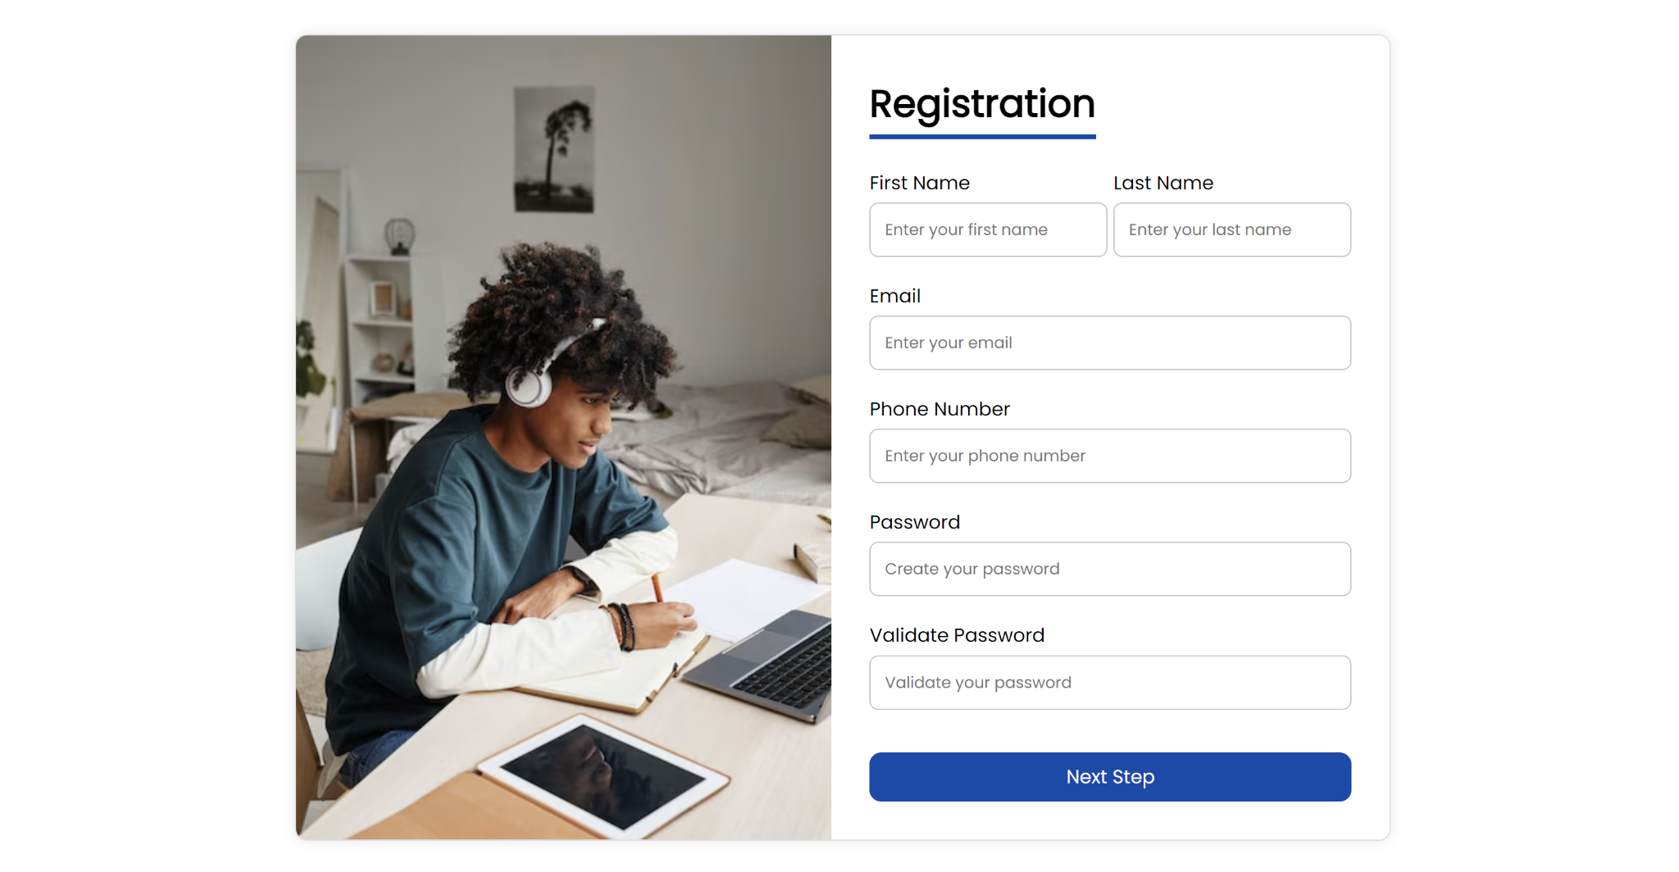

* 1200px and lower

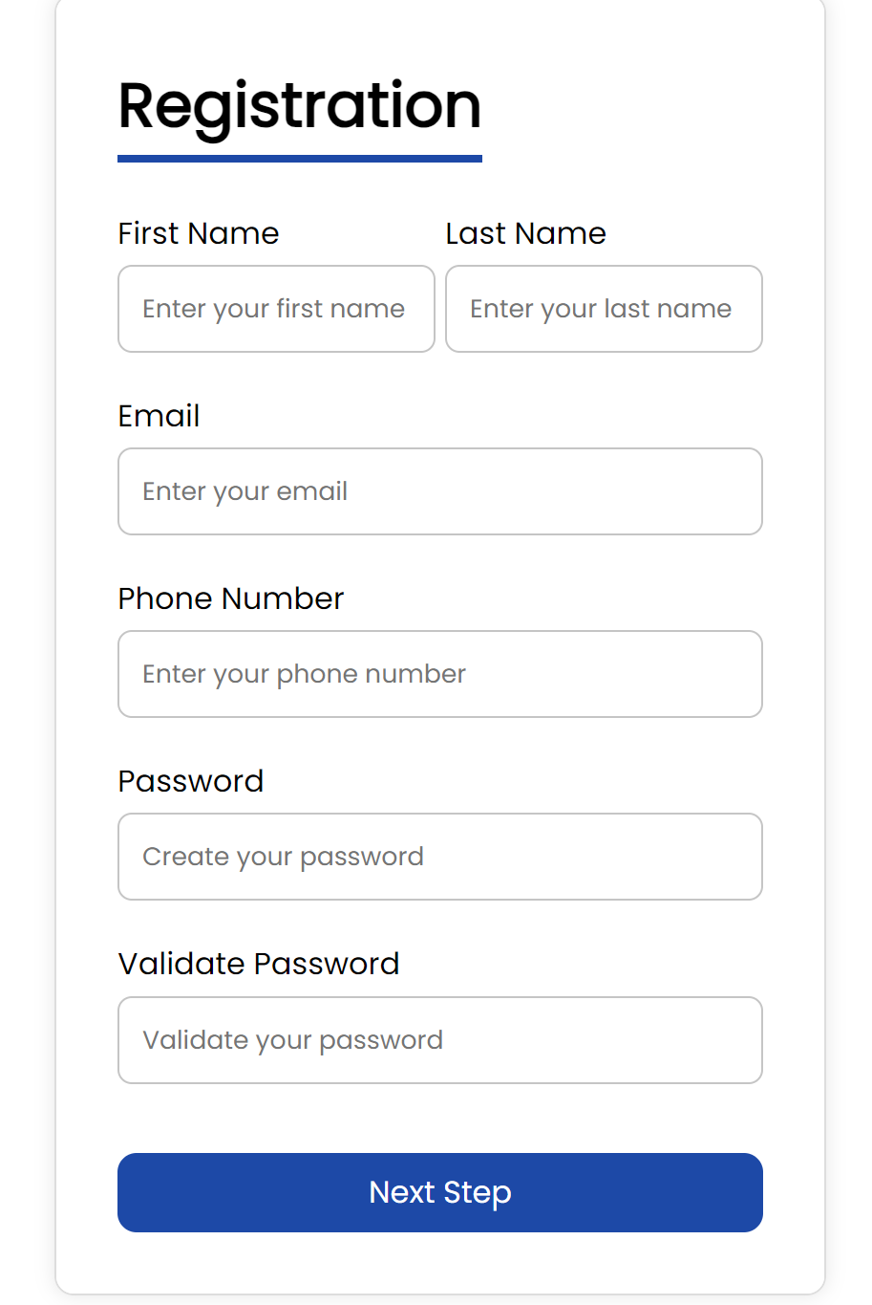

1. **Reference of Additional File**

* arrow: <https://www.stockio.com/free-icon/arrow-right-3>
* dummy-video: <https://www.youtube.com/watch?v=D0UnqGm_miA>
* header: <https://undraw.co/illustrations>
* check: <https://www.google.com/url?sa=i&url=https%3A%2F%2Fwww.iconexperience.com%2Fo_collection%2Ficons%2F%3Ficon%3Dcheck&psig=AOvVaw3s_3CmD2NEPtBlFR6OC8Rd&ust=1718343094821000&source=images&cd=vfe&opi=89978449&ved=0CBIQjRxqFwoTCOCG7YDt14YDFQAAAAAdAAAAABAJ>
* icon-1: <https://www.google.com/url?sa=i&url=https%3A%2F%2Ffavpng.com%2Fpng_view%2Fthinking-man-learning-education-icon-design-png%2F7jpr7xJS&psig=AOvVaw0cpUahireHVWKQpCF0NJtm&ust=1718343154488000&source=images&cd=vfe&opi=89978449&ved=0CBIQjRxqFwoTCKC5lJzu14YDFQAAAAAdAAAAABAE>
* icon-2: <https://www.google.com/url?sa=i&url=https%3A%2F%2Fwww.hiclipart.com%2Ffree-transparent-background-png-clipart-jajhc&psig=AOvVaw3nqbGXm8fhy9ufYsAD_KHY&ust=1718343032653000&source=images&cd=vfe&opi=89978449&ved=0CBIQjRxqFwoTCJDjo-Ps14YDFQAAAAAdAAAAABAJ>
* icon-3: <https://www.google.com/url?sa=i&url=https%3A%2F%2Fin.pinterest.com%2Fpin%2Fdownload-open-book-gray-icon-symbol-png--785807834991589343%2F&psig=AOvVaw3ph8RHU_tofTE4yixQy0Vh&ust=1718343465512000&source=images&cd=vfe&opi=89978449&ved=0CBIQjRxqFwoTCJDPhLLu14YDFQAAAAAdAAAAABAE>
* icon-4: <https://www.google.com/url?sa=i&url=https%3A%2F%2Fwww.hiclipart.com%2Fsearch%3Fclipart%3DProgress%2BIcon&psig=AOvVaw3O4_ava-gGjuDqLqy49vdu&ust=1718343496711000&source=images&cd=vfe&opi=89978449&ved=0CBIQjRxqFwoTCMDLvsfu14YDFQAAAAAdAAAAABAE>
* icon-5: <https://www.google.com/url?sa=i&url=https%3A%2F%2Fin.pinterest.com%2Fpin%2Fpeople-conversing-talking-white-icon-hd-png--785807834992149212%2F&psig=AOvVaw0t8n-WDiYz4V6uDh6THX1A&ust=1718343586805000&source=images&cd=vfe&opi=89978449&ved=0CBIQjRxqFwoTCIiFtevu14YDFQAAAAAdAAAAABAR>
* logo: <https://www.canva.com/design/DAGFjsWMidg/rPtWPUbCgKYIgQ46oprhCQ/edit?utm_content=DAGFjsWMidg&utm_campaign=designshare&utm_medium=link2&utm_source=sharebutton>
* profile: <https://www.google.com/url?sa=i&url=https%3A%2F%2Ficonduck.com%2Ficons%2F180867%2Fprofile-circle&psig=AOvVaw1VASKVjakZVGDgWpXwJn9S&ust=1718343682000000&source=images&cd=vfe&opi=89978449&ved=0CBIQjRxqFwoTCJCarpnv14YDFQAAAAAdAAAAABAE>
* study-portrait: <https://www.google.com/url?sa=i&url=https%3A%2F%2Fwww.freepik.com%2Fpremium-photo%2Fvertical-portrait-africanamerican-teenage-boy-studying-home-college-dorm-using-laptop_19991852.htm&psig=AOvVaw0Vg9zNRM6fcMtDVHE7-5Me&ust=1718343993377000&source=images&cd=vfe&opi=89978449&ved=2ahUKEwjBrvGr8NeGAxW9bmwGHWhXBQEQjRx6BAgAEBU>
* thumbnail-1: <https://www.google.com/url?sa=i&url=https%3A%2F%2Fwww.youtube.com%2Fwatch%3Fv%3DKxEzqLpv1Vw&psig=AOvVaw3hdf-3iNnTgZcoF0YuXUzM&ust=1718344095371000&source=images&cd=vfe&opi=89978449&ved=0CBIQjRxqFwoTCKi18d3w14YDFQAAAAAdAAAAABAE>
* thumbnail-2: <https://www.google.com/url?sa=i&url=https%3A%2F%2Fwww.youtube.com%2Fwatch%3Fv%3DHe60p3MFf-M&psig=AOvVaw3D6j6YEMil5kreDnVR-65R&ust=1718346806800000&source=images&cd=vfe&opi=89978449&ved=0CBIQjRxqFwoTCKiy7ur614YDFQAAAAAdAAAAABAJ>
* thumbnail-3:

<https://www.google.com/url?sa=i&url=https%3A%2F%2Fwww.youtube.com%2Fwatch%3Fv%3DZCHKDii5HrY&psig=AOvVaw1_zcr3VFwwzbBgD4cVBIik&ust=1718346839943000&source=images&cd=vfe&opi=89978449&ved=0CBIQjRxqFwoTCMC4rYz714YDFQAAAAAdAAAAABAE>

* thumbnail-4: <https://www.google.com/url?sa=i&url=https%3A%2F%2Fwww.youtube.com%2Fwatch%3Fv%3DOualsHB1FqE&psig=AOvVaw2D2JDjDgpwwnwAzn6PT_eE&ust=1718346898513000&source=images&cd=vfe&opi=89978449&ved=0CBIQjRxqFwoTCNiRw5b714YDFQAAAAAdAAAAABAE>
* thumbnail-5: <https://www.google.com/url?sa=i&url=https%3A%2F%2Fwww.youtube.com%2Fplaylist%3Flist%3DPLAhk31i50JpzWo_hEY4j9GXZ4Zdf0W1ib&psig=AOvVaw3rQaIbJZgsT9N8EDPLai7w&ust=1718346917881000&source=images&cd=vfe&opi=89978449&ved=0CBIQjRxqFwoTCKDLh6H714YDFQAAAAAdAAAAABAE>
* thumbnail-6: <https://www.google.com/url?sa=i&url=https%3A%2F%2Fwww.youtube.com%2Fwatch%3Fv%3DjDM7keVfENI&psig=AOvVaw12DpLKqsND0VlgXQ2P1DLM&ust=1718346960444000&source=images&cd=vfe&opi=89978449&ved=0CBIQjRxqFwoTCICHhLT714YDFQAAAAAdAAAAABAE>
* thumbnail-7: <https://www.google.com/url?sa=i&url=https%3A%2F%2Fwww.youtube.com%2Fwatch%3Fv%3DEXG2Z1RpVwU&psig=AOvVaw3SvC6DpKOPEVg5sZ9q4GbD&ust=1718346994198000&source=images&cd=vfe&opi=89978449&ved=0CBIQjRxqFwoTCMiP7cX714YDFQAAAAAdAAAAABAE>
* thumbnail-8: <https://www.google.com/url?sa=i&url=https%3A%2F%2Fwww.aatoonsstudy.com%2Ftable-of-cell-structure-and-functions-aatoons-study%2F&psig=AOvVaw2KoWZ8gJ6sul91DUvsJMn9&ust=1718347018212000&source=images&cd=vfe&opi=89978449&ved=0CBIQjRxqFwoTCMi14NP714YDFQAAAAAdAAAAABAO>
* thumbnail-9: <https://www.google.com/url?sa=i&url=https%3A%2F%2Fwww.youtube.com%2Fwatch%3Fv%3D3g8djSKP7Qo&psig=AOvVaw3VX6SO2HD88ZflNHT8WU9t&ust=1718347141985000&source=images&cd=vfe&opi=89978449&ved=0CBIQjRxqFwoTCIiL24r814YDFQAAAAAdAAAAABAE>
* thumbnail-10: <https://www.google.com/url?sa=i&url=https%3A%2F%2Fwww.youtube.com%2Fwatch%3Fv%3DKHwXl0_Pgjs&psig=AOvVaw0YdZcKsM8AkMY4pMpeC07A&ust=1718347160257000&source=images&cd=vfe&opi=89978449&ved=0CBIQjRxqFwoTCNCx1ZP814YDFQAAAAAdAAAAABAE>
* thumbnail-11: <https://www.google.com/url?sa=i&url=https%3A%2F%2Fwww.youtube.com%2Fwatch%3Fv%3DTYEYEIuTmGQ&psig=AOvVaw1PXMK9l4CczvDOi50t4cpW&ust=1718347190357000&source=images&cd=vfe&opi=89978449&ved=0CBIQjRxqFwoTCJiK2qH814YDFQAAAAAdAAAAABAE>
* thumbnail-12: <https://www.google.com/url?sa=i&url=https%3A%2F%2Fwww.youtube.com%2Fwatch%3Fv%3DuYjRzbP5aZs&psig=AOvVaw2WvyemIzR5bApFHjkb-l65&ust=1718347215893000&source=images&cd=vfe&opi=89978449&ved=0CBIQjRxqFwoTCKCKwK7814YDFQAAAAAdAAAAABAE>
* thumbnail-13: <https://www.google.com/url?sa=i&url=https%3A%2F%2Fm.youtube.com%2Fwatch%3Fv%3DYw8azUV_vW8&psig=AOvVaw21wEyumXH_dNxk9TKKHAzj&ust=1718347238555000&source=images&cd=vfe&opi=89978449&ved=0CBIQjRxqFwoTCIC92rj814YDFQAAAAAdAAAAABAE>
* thumbnail-14: <https://www.google.com/url?sa=i&url=https%3A%2F%2Fwww.youtube.com%2Fwatch%3Fv%3DdxLLJVgOr7A&psig=AOvVaw1jQVBgCee-JK5ynV7rVyT2&ust=1718347256441000&source=images&cd=vfe&opi=89978449&ved=0CBIQjRxqFwoTCIjZmcH814YDFQAAAAAdAAAAABAE>
* thumbnail-15: <https://www.google.com/url?sa=i&url=https%3A%2F%2Fwww.youtube.com%2Fwatch%3Fv%3DhD9arWXIddM&psig=AOvVaw0nGNywK9BPTt1_XhZueJuk&ust=1718347274646000&source=images&cd=vfe&opi=89978449&ved=0CBIQjRxqFwoTCOjU9cn814YDFQAAAAAdAAAAABAE>

1. **How to use my application**
2. Navbar

My website implements a responsive navigation bar that adapts to different screen sizes. It lists internal navigation links for different pages of the website, which is Home, Learn, Subscription, Testimony, and Register. For larger screens, the navigation menu is displayed inline. If the screen is smaller than 768px, it becomes a hamburger menu. The .nav-toggle button is initially hidden and becomes visible on smaller screens. When the button is clicked, it toggles the .active class on the nav element, which changes the navigation menu's display from none to flex to make it visible. The script also adjusts the padding-top of the main element so the content below is not blocked by the navbar.

1. Footer

My footer is used to show additional links in an organized manner. The footer contains .footer-container that is divided into four .footer-column sections. The first column displays the Jenius Academy logo. The second column shows links for all of the pages for my website, just like the navbar. The third column includes links to social media platforms like Youtube, Facebook, Instagram, Twitter, and LinkedIn. The fourth column provides company-related links, such as Privacy Policy and Terms and Service. Below the columns, there is a text for copyright notice.

1. Home Page

My home page contains 4 sections, which are hero, features, best-selling subscription packages, and frequently asked questions.

The hero section of the homepage is designed to immediately capture the user's attention and provide a clear and concise introduction to Jenius Academy. The section is split into two parts. On the left, there is a headline, a brief description of the platform's mission, and a call-to-action (CTA) register button. On the right, there is an image. When the screen is 768px or lower, the image is not shown so that the hero section is not too crowded.

The features section highlights the features offered by Jenius Academy. It includes a header and 5 feature cards, each with an icon, title, and brief description.

The subscription section provides detailed information about the available subscription plans. It includes three packages: Starter, Ultimate, and Advanced. Each package is presented in a card format with a title, price, description, a list of features (with checked items indicating available features and grayed-out checks for unavailable ones), and a "Pick Plan" button. The Ultimate plan is highlighted with a slightly larger scale to draw attention.

The FAQ section addresses common questions potential users might have about Jenius Academy. Each question is presented in a collapsible format with a "+" symbol that can be clicked to reveal the answer. When the answer is shown, the “+” symbol becomes a “-” symbol. When clicked it will hide the answer like default. This interaction improves the user experience by allowing users to expand and collapse questions as needed, keeping the page clean and organized.

1. Learn Page

The Learn page is designed to show educational video courses across different educational levels, including UTBK, International University, High School, Middle School, and Elementary School. Each section features a set of course cards displaying a video thumbnail, video duration, tutor profile, and course details. Courses are initially divided into visible and hidden sections. By default, only the first few courses are shown, and the rest are hidden. Each section includes a "Show More" button that, when clicked, reveals the hidden courses. The hidden courses become visible, and the button text changes to "Show Less" to allow users to hide the extra courses again. This functionality enhances the user experience by keeping the page clean and manageable while still providing access to additional content. This interaction is implemented using JavaScript to toggle the visibility of the course cards when the corresponding button is clicked. The learn page is also responsive. When the screen is larger than 1200px, it shows 3 videos in each row. When the screen is 769-1200px, it shows 2 per row. And when it is 768px or lower, it shows 1 for each line.

1. Subscription Page

The Subscription page features a carousel showcasing three subscription plans which are Starter, Ultimate, and Advanced. The carousel allows users to navigate through the plans using previous and next buttons, with transitions to highlight the currently selected plan. The page is designed to be responsive, ensuring a seamless experience across different screen sizes. On screens smaller than 1200px, the carousel adjusts to show one plan at a time. For screens smaller than 768px, the layout adapts to fit the content vertically and adjust text sizes appropriately.

1. Testimony Page

The Testimony page shows the positive feedback from users, featuring a series of testimonials displayed in a visually appealing card format. Each testimonial includes a profile section with the user’s profile picture, name, and subscription package. Below the profile, a brief feedback message is displayed, with some testimonials including a "Show more" link to reveal the full text if the text is quite long. This interactive element enhances user engagement by allowing visitors to read detailed experiences shared by other users.

1. Register Page

The registration page allows users to sign up by entering their first name, last name, email, phone number, and password. The form is visually divided into two sections: an image of a student studying on one side and the registration form on the other. Upon submission, the form validates the input fields to ensure they are not empty, the email is in the correct format, the password is at least 10 characters long and contains at least one number, and that the password matches the confirmation field. If any validation fails, an error message is displayed below the respective input field, and form submission is halted. The form's design is responsive, adjusting to different screen sizes by hiding the image on smaller screens and stacking the form elements vertically. The JavaScript code also adjusts the height of the image to dynamically match the form's height.